PYTHON Data types

Built-in Data Types

In the programming "*data type*" It's a very important concept;

Variants can hold values of different types, and different types can do different things;

Python has the following built-in data types:

1. Text type: str;
2. Numeric types: int, float, complex;
3. Sequence types: list, tuple, range;
4. Mapping type: dict;
5. Set types: set, frozenset;
6. Boolean type: bool;
7. Binary types: bytes, bytearray, memoryview;
8. None type: NoneType;

As we've learned before, you can find the type of any variable by doing the following:

Setting the data type

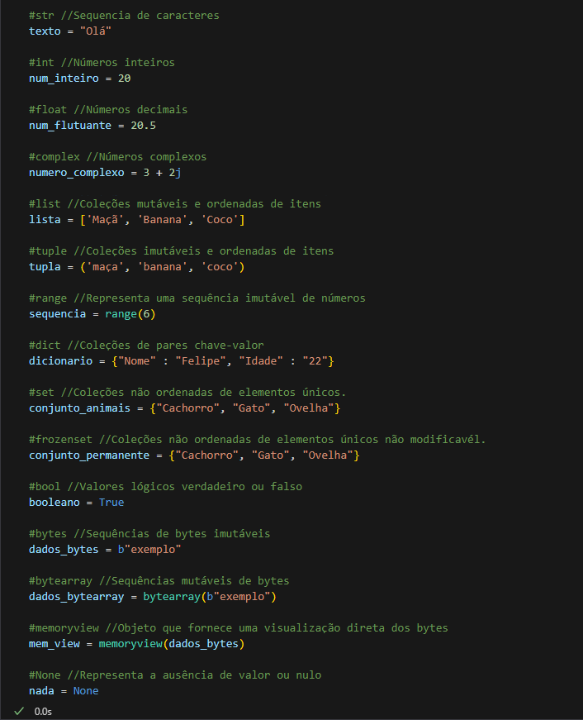 In python, the data type is defined when you assign a value to the variable:

There is no need to specify the data type, but if you want, just put the type_name (value) before the value